# NO SQL LAB-1

**Question**

(**Week8**)

Perform the following DB operations using MongoDB.

1. Create a database “Student” with the following attributes Rollno, Age,ContactNo, Email-Id.

2. Insert appropriate values

3. Write query to update Email-Id of a student with rollno 10.

4. Replace the student name from “ABC” to “FEM” of rollno 11.

5. Export the created table into local file system

6. Drop the table

7. Import a given csv dataset from local file system intomongodb collection.

**Create database**

db.createCollection("Student");



**create table**

db.Student.insertMany([{rollno:1,age:21,cont:9876,email:"prannay@gmail.com"},{rollno:2,a

ge:22,cont:9976,email:"sohan@gmail.com"},{rollno:3,age:21,cont:5576,email:"farhan@gmail.com"},{rollno:4,age:20,cont:4476,email:"sakshi@gmail.com"},{rollno:5,age:23,cont:2276,email:"sanika@gmail.com"}]);

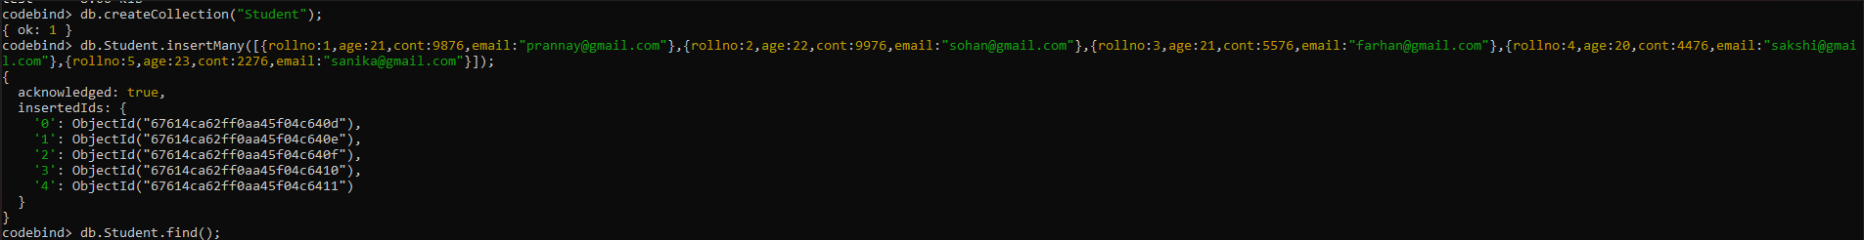

db.student.find();

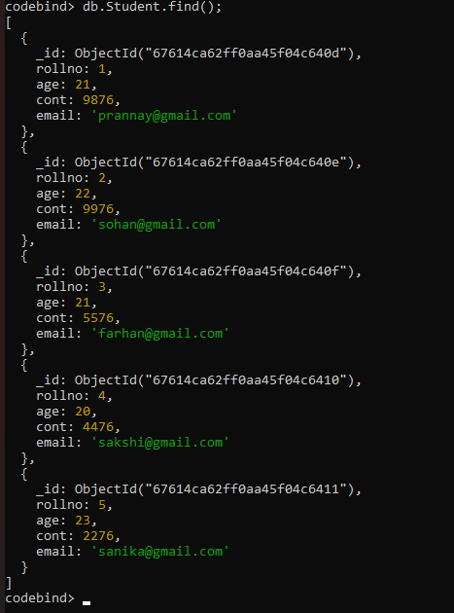

**Queries**

1.Write query to update Email-Id of a student with rollno 10.

db.Student.update({rollno:5},{$set:{email:"abhinav@gmail.com"}});

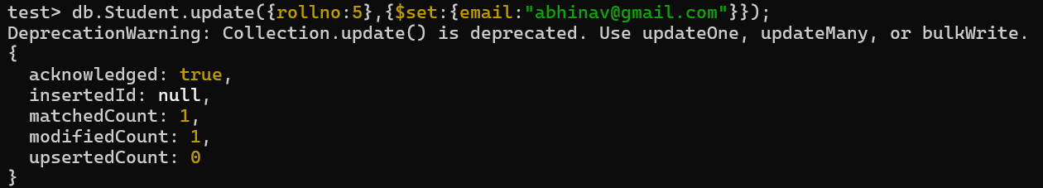

2.Replace the student name from “ABC” to “FEM” of rollno 11.

db.Student.insert({rollno:11,age:22,name:"ABC",cont:2276,email:"madhura@gmail.com"}); db.Student.update({rollno:11,name:"ABC"},{$set:{name:"FEM"}})

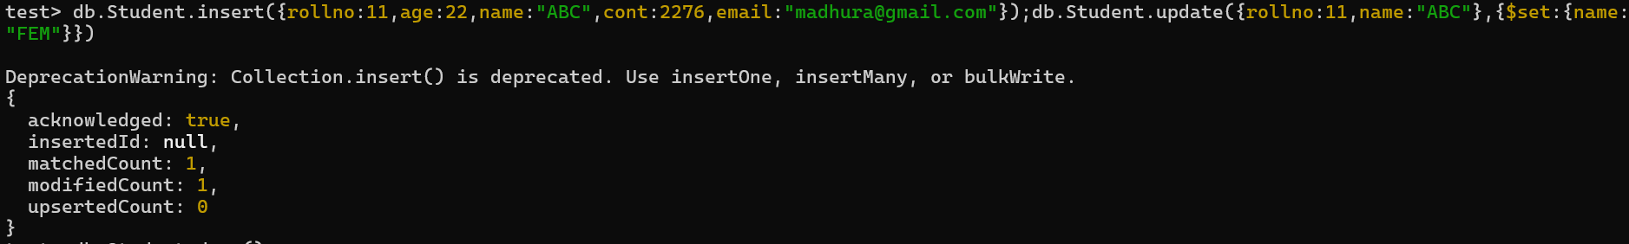

3. Export the created table into local file system

mongoexport mongodb+srv://204:<password>@cluster0.xbmgopf.mongodb.net/test

--collection=Student -- outC:\Users\college\Documents\test.Students.json

4. Drop the table

db.Student.drop();

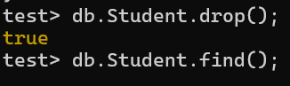

5. Import a given csv dataset from local file system into mongodb collection.

mongoimport mongodb+srv://204:<password>@cluster0.xbmgopf.mongodb.net/test

--collection=Student –type json –file C:\Users\college\Documents\test.Students.json

db.Student.find();

